Measure Fish Size

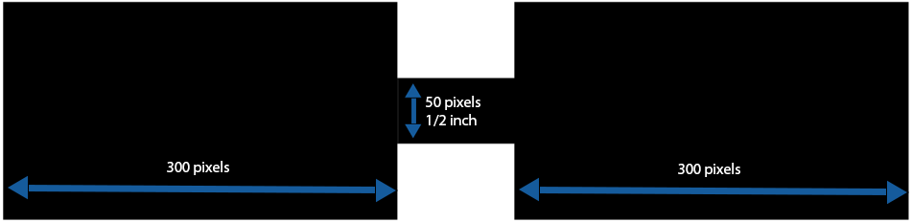To measure the fish size, we used the information that mentions that the diameter of the PVC pipe that elongates the two pieces of the fish is ½ inch. Knowing that diameter in inches and in pixels helps us to consider it as a reference to measure the length of each piece of the fish by measuring it in pixels and then doing mathematical calculations using ratio between inches and pixels to get the length of the fish in inches since we have the length in pixels.

300 pixels + 300 pixels = 600 pixels

50 pixels = ½ inch

**Therefore:**

600 pixels / X inches = 50 pixels / ½ inch

**Therefore:**

X = (600 pixels / 50 pixels) * ½ inch = 6 inches